Project Update Report #1

My application is currently capable of fully working, multi-user chat. The client is capable of displaying either all the new chat logs since the last message its user sent (default functionality), or it can display the entire chat log if requested. I have begun the process of implementing emoji support, but that isn’t quite working yet. A user is also capable of shutting down the server for now although this functionality will probably be removed once the application nears completion. I plan to add the functionality that when the server closes, it will notify all currently connected users. I also plan to add a roll call function where a user is able to view a list of all currently connected users.

The server is capable of saving the chat log to a text file, although it is only currently set to do so when it receives a command from the client to shut down the server. This text file displays the date the chat log was saved, a list of all the users who connected to the server during its lifetime, and finally the entire chat log.

SERVER SIDE EXAMPLE: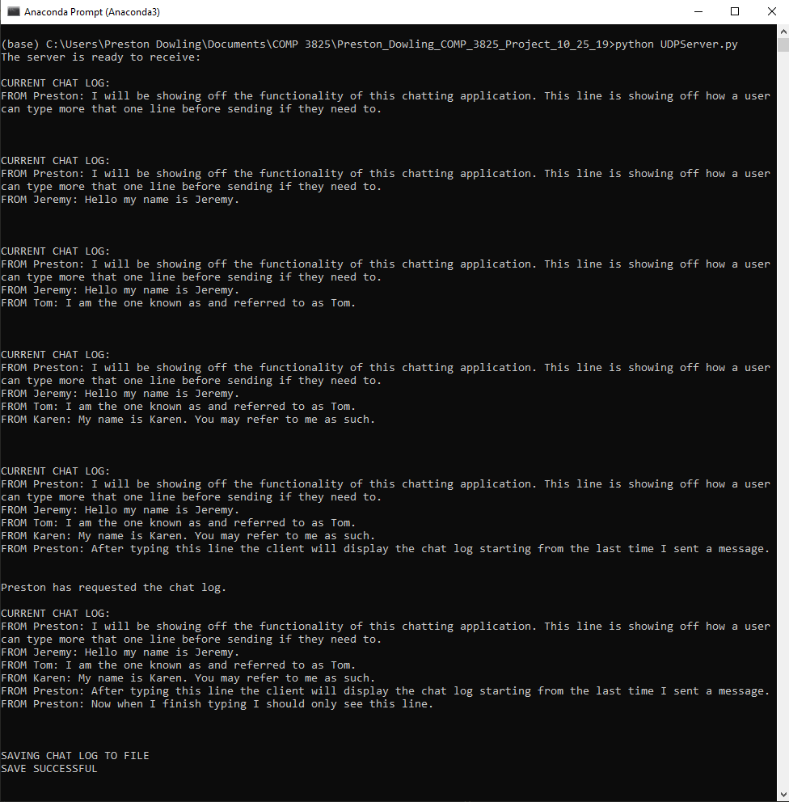

CHAT LOG SAVED FILE EXAMPLE:

